VIETNAM GENERAL CONFEDERATION OF LABOUR

**TON DUC THANG UNIVERSITY**

**FACULTY OF INFORMATION TECHNOLOGY**



**THE FINAL PROJECT OF SOFTWARE TECHNOLOGY**

**CONVENIENCEN STORE**

Instructor : **M.Sc LÊ NGỌC THẠCH**

Executor: **LÊ TUẤN KIỆT– 518H0523**

**LỮ TRỌNG PHÚ – 518H50523**

**TRẦN NGUYỄN HOÀNG MINH – 518H0523**

Class     **:    18H50202**

Course    **:    22**

**HO CHI MINH CITY,  2020**

**THANKS**

During the research process for the major assignment, I have received enthusiastic suggestions and help from teachers, so this sincere thanks would be send to:

* Firstly, I would like to express my sincere gratitude to my supervisor teacher - M.Sc LÊ NGỌC THẠCH, who taught and conveyed experiences to me directly during my studying and conducting this research process.
* Besides, I am thoroughly grateful to all teachers of the Faculty of Information Technology in TDT University for giving me a chance to study and contact with my major.

**THIS PROJECT WAS ACCOMPLISHED AT TON DUC THANG** **UNIVERSITY**

I commit that this product belongs to us with the guardian of M.Sc LÊ NGỌC THẠCH. The content of the research, result of this project is honest and has not been published in any form before. The data in the tables for analysis, comment and evaluation were collected by the author from various sources in the reference section.

Besides, our project used many kinds of comments, assessments as well as data from other authors, organizations. This project has original quotes and annotations.

If any fraud is detected, I will take full responsibility for the contents of my project. Ton Duc Thang University is not involved to any violations of copyright and copyright caused by me during implementation (if any).

*Ho Chi Minh City, November 30th, 2020*

*Author*

*(Sign and write full name)*

*Lê Tuấn Kiệt*

*Lữ Trọng Phú*

*Trần Nguyễn Hoàng Minh*

**CONFIRMATION AND EVALUATION OF LECTURERS**

**Confirmation of lecturers**

_____________________________________________________________________________________________________________________________________________________________________________________________________________________________________________________________________________________________________________________________________________________________________

Ho Chi Minh City, May 17th 2020

(Sign and write full name)

**Evaluation of lecturers**

_____________________________________________________________________________________________________________________________________________________________________________________________________________________________________________________________________________________________________________________________________________________________________

Ho Chi Minh City, May 17th 2020

(Sign and write full name)

**CHAPTER 1 : EXECUTIVE SUMMARY**

1. **Introduction**
   1. **Description**

* Sales management system aims to create a sales management system including the functions:

+ Employee management.

+ Customer management.

+ Manage import and export.

+ Manage existing items in the store

+ Financial management, revenue and expenditure of the store

* The system design will be released under the title of Convience Store and the initial release is expected to be 1.0 (though this is subject to change). Further iterations of the application are bound to occur and thus this first system should be considered as the base model with room to grow and evolve as the end customer’s requirements change.
* It is expected that the relevant test and development plan documents will be created based on the information provided within this document and should be referenced accordingly.
* Convience Store workflow will be in three deliverables.
* Use case model survey: Use case model survey includes a list of actors and use case diagrams.
* Domain object model (optional): The deliverables of this activity are collaboration, sequence, and class diagrams for each use case.
* Detailed use case description for every use case: These documents drive the development in future phases of developing a software system.
  1. **Actor**
* Customer:

+ Customers are people who buy from the store.

* Staff:

+ Staff will manage the number of goods in the warehouse, inventorying the goods.

+ The salesman will make a bill for customers.

* The Store Manager:

+ The Store Manager will directly contact the manufacturer to import goods into the store, as well as have a relationship with partners to sell out. The Store Manager will manage employee information in the store.

**CHAPTER 2 : BUSINESS REQUIREMENTS**

1. **Mô tả**
2. **List of use cases**

|  |  |
| --- | --- |
| Uses Cases | Use Cases Goals |
| Khách hàng | * Tìm kiếm mặt hàng * Mua hàng * Xác nhận đơn đặt hàng * Tư vấn mặt hàng |
| Nhân viên bán hàng | * Đăng nhập hệ thống mặt hàng * Lập hóa đơn |
| Thủ kho | * Nhập hàng * Kiểm tra hàng * Cập nhật hàng |
| Người quản lí | * Thống kê * Quản lí hàng * Quản lí nhân viên |

1. **List of actors**
2. Khách hàng

- Khách hàng là người lựa chọn và mua hàng trong cửa hàng.Khách hàng có trách nhiệm phản hồi lại về bộ phận người quản lí nếu có gì sai sót ảnh hưởng đến quyền lợi khách hàng.

1. Nhân viên bán hàng

- Nhân viên bán hàng là người tiếp nhận mặt hàng hoặc giỏ hàng từ khách hàng , tính tiền , thu tiền và đưa biên lai cho khách hàng.Và là người tư vấn cho khách hàng đi mua mặt hàng.

1. Thủ kho

- Thủ kho là người nhập hàng, kiểm tra ,cập nhật số dữ liệu về mặt hàng hiện có trong kho.

1. Người quản lí

- Người quản lí là người chịu tránh nhiệm về quản lí khách hàng,nhân viên,tài chính,doanh thu của cửa hàng.

1. **Use case diagram**

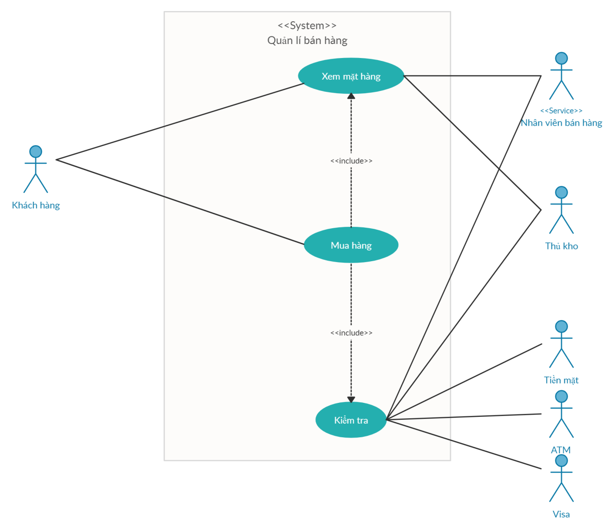

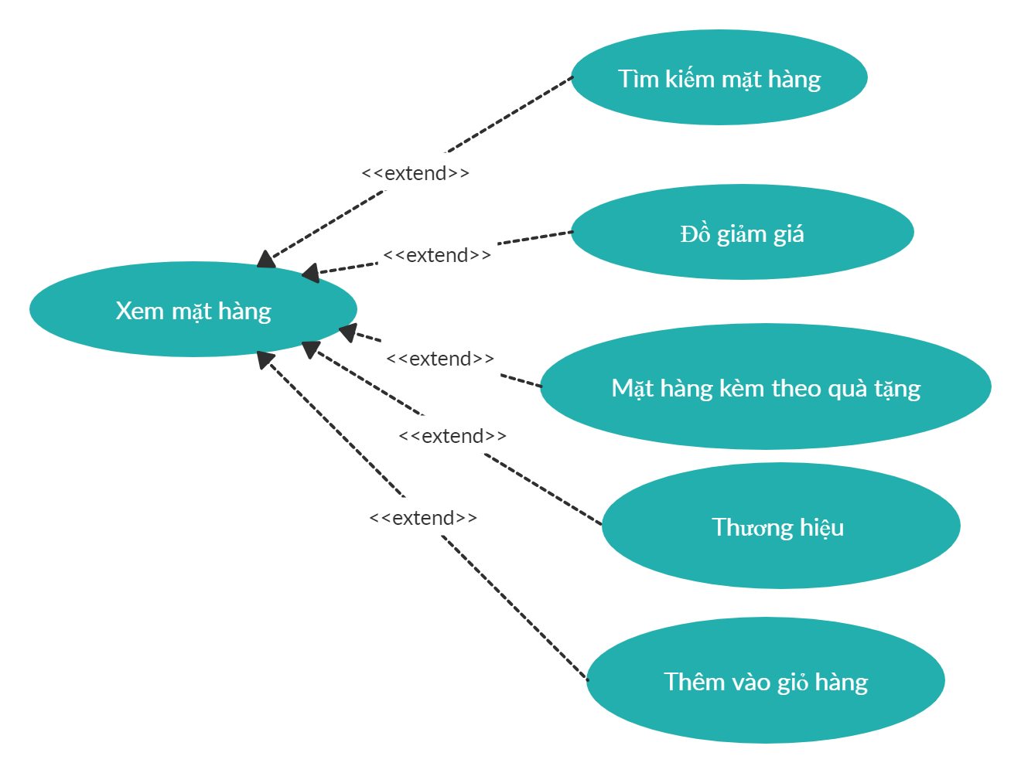

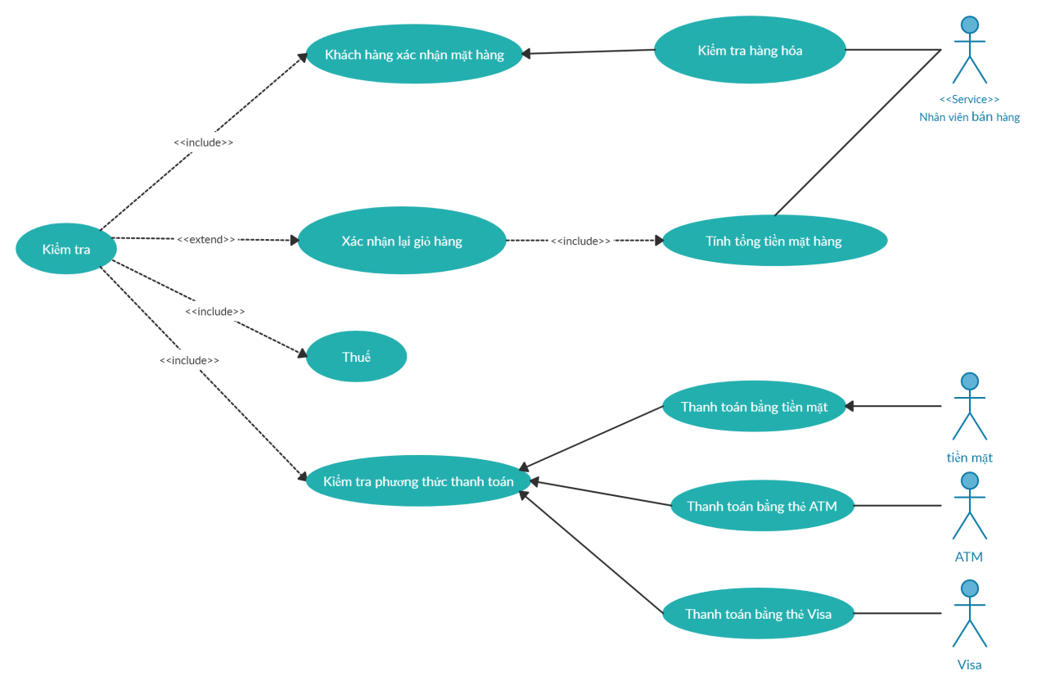

1. **Code**
2. **Demo**